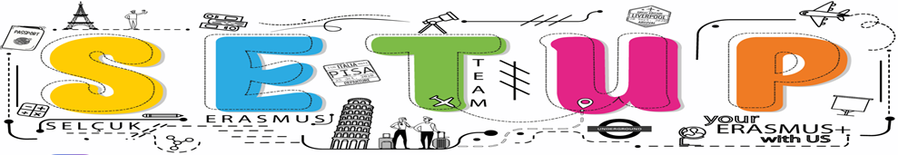

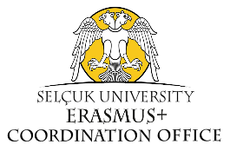
THEMATIC PARTNERSHIP FORM FOR ERASMUS+
(Blended Intensive Programme (BIP))

If you need further support or have any questions, please contact e-mail: erasmus@selcuk.edu.tr

ERASMUS SUBJECT AREA /CODE
POLITICAL SCIENCE/INTERNATIONAL RELATIONS (Code.313/316)
Coordinator/Host University
Expected Partners
Thematic Focus
Coordinator Faculty/ Department

Relevant Features of the Faculty/Department
Venue for the in-person study period
Time Period
In-person attendance period

Virtual attendance period
Language of instruction
ECTS

Thank you!
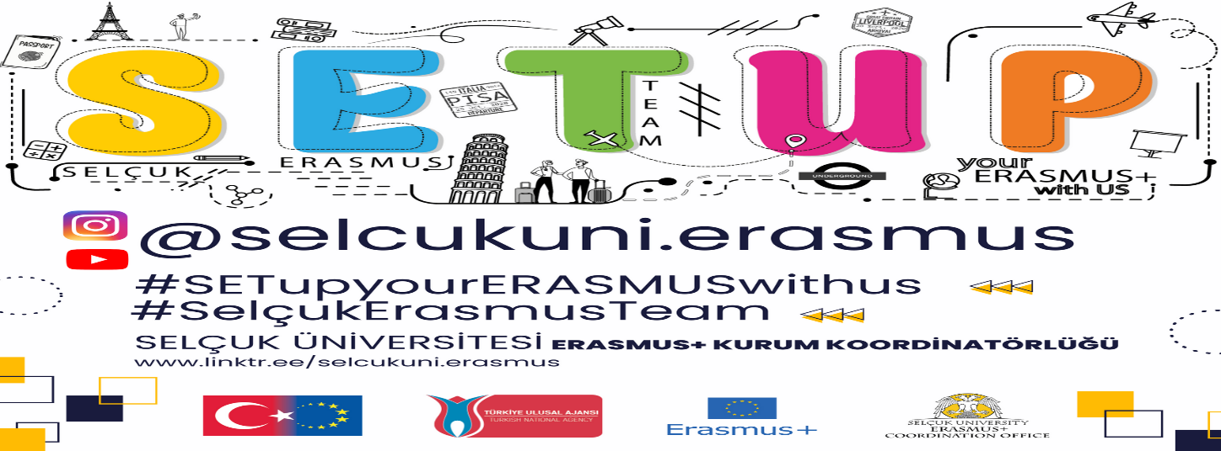

See at: https://www.selcuk.edu.tr/Birim/Bolum/iktisadi_ve_idari_bilimler-uluslararasi_iliskiler/15330#.

